Baking Masterclass
This half term saw the return of our very popular baking masterclasses, kindly hosted by Mrs Zachariah. The class was fully booked within an hour of places being made available and 12 parents, some accompanied by their sons, learnt how to make shortcrust pastry in the form of a lemon tart. Donations for participating in this, and previous classes, will be used by the Food Tech department to buy a digital camera for photographing all types of food and techniques. Our thanks to Mrs Zachariah for continuing to run these classes – we hope to run another in the Autumn Term – look out for an email and adverts on the FoS website, www.friendsofwbgs.org

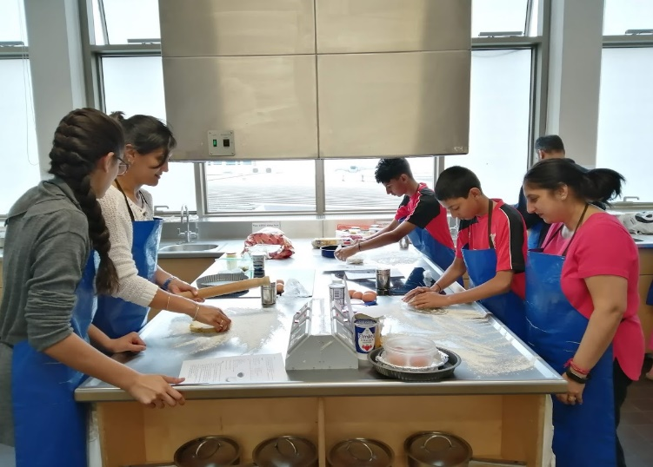
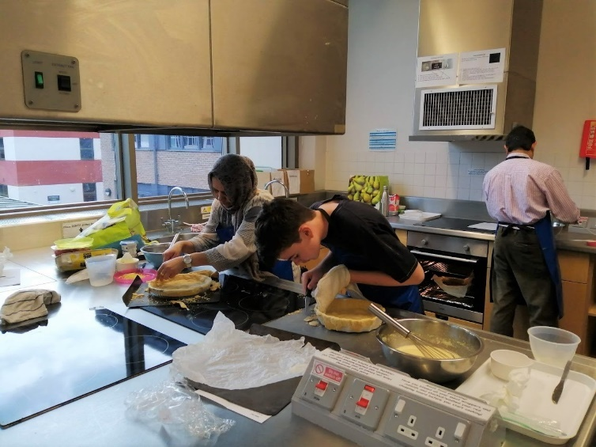

New to Year 7 Fun Day
As usual the Friends of School provided the food and refreshments at the New to Year 7 Fun Day on 6th July where all boys joining WBGS in September and their families were welcomed into school to meet their new classmates and take part in team-building activities. A big thank you to all the parents and the prefect team who volunteered to help on the day. It was a busy, but enjoyable day, and hopefully all the new Year 7s are looking forward to joining our school community in September.

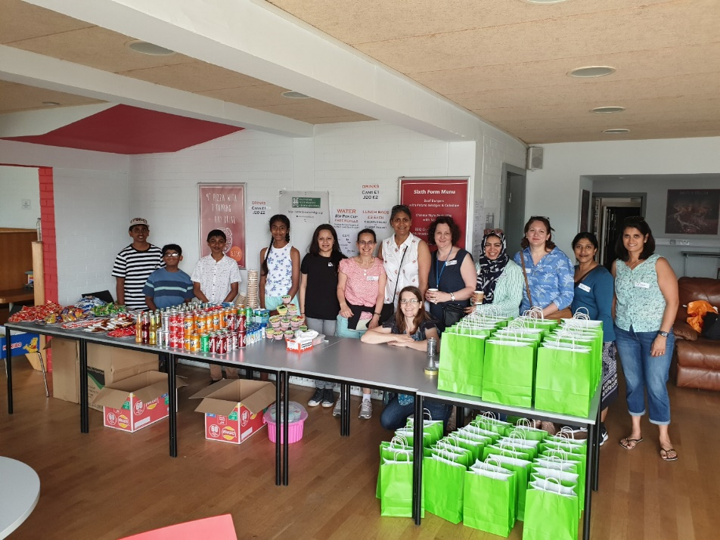

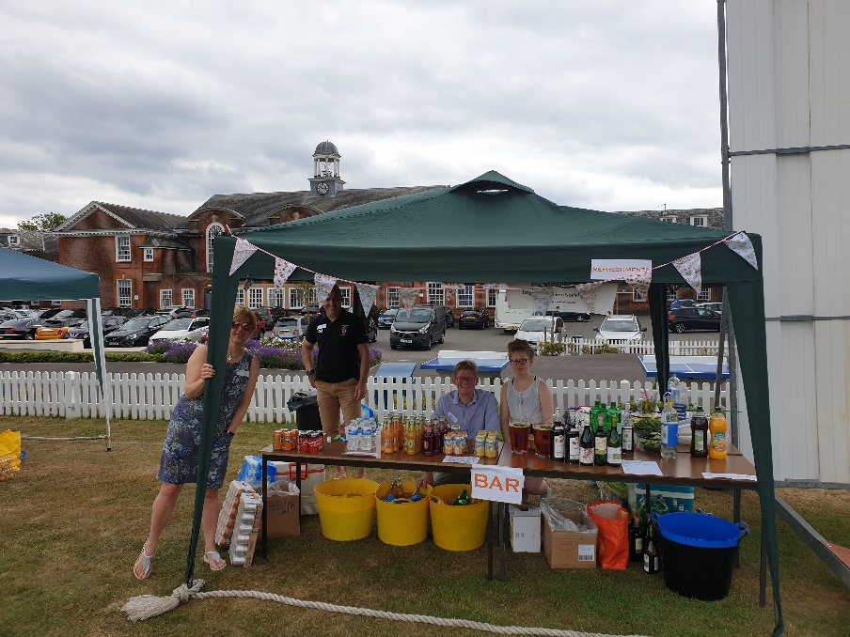
Family Draw
The Family Draw was drawn as usual and this term’s winner is number 41 - John O'Sullivan who won £48.43
If you don’t currently participate in the Family Draw but would like to do so, please get in touch for a form info@friendsofwbgs.org . As well as raising valuable funds for the school you will be in with the chance of winning a cash prize each term.
Thank you
Lastly, The Friends of School would like to say a big thank you to everyone who has supported our activities this year, be it attending or helping out at an event, serving refreshments at a concert or parents evening, or buying a ticket for the Big Raffle. Your help and support are invaluable in enabling us to raise much-needed funds for the school. This year we are pleased to report that we have met our target of raising enough money to purchase a new bicycle shed. This will be installed over the Summer break and will hopefully encourage more boys to cycle to school next year. Thank you!
Wishing you and your families a happy, peaceful and sunny summer break.
The Friends of WBGS.

Some Diary Dates for 2019-20
Monday 16th September – 1st Friends of School meeting of the new academic year – All are welcome
Saturday 9th November – Comedy Night held jointly with WGGS – Tickets on sale in September
Saturday 7th March 2020 – Annual Quiz Night

